MaUWB_AOA Gen2 Tag Data Sheet
version: 1.0
by: Leobo
目录
MaUWB_AOA Gen2 Tag Data Sheet 1
1. Product Introduction 1
1.1 Product Introduction 1
1.2 Product Features 2
1.3 Application objects 3
2. Module Hardware Specifications 4
2.1 Module Hardware Pin Definitions 4
2.2 Module hardware packaging dimensions 5
3. Communication Protocol Description 6
3.1 Base Station Positioning Frame 6
3.2 Base station positioning frame RSSI 8
3.3 Tag Configuration Frame 10
3.4 OTA upgrade frame 10

Product Introduction

Product Introduction
Makerfabs Electronics' MaUWB_AOA Gen2 Tag is a patch-type tag module specifically designed for the MaUWB-AOA positioning system and is used in conjunction with MaUWB_AOA Gen2 Anchor. The module continuously emits UWB signals, and the base station receives them to calculate the relative distance and angle of the wearer, enabling automatic following of equipment such as luggage carts, AGVs, and service robots. The bare board module has a shape suitable for customers to embed into their own products for secondary customization development. The entire system has a measurement error of less than 10 cm, an angle error of less than 5°, a maximum visible distance of 50 meters, and is not affected by light interference, outperforming visual and ultrasonic following solutions.

Follow tag: MaUWB_AOA Gen2 Tag module
Product Images | 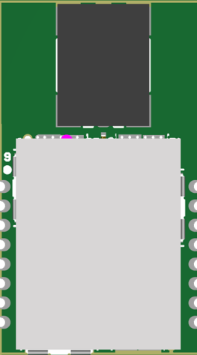
External dimensions | 13mm*23mm*2mm
Product Weight | 1.5g
Power supply method | 3.3V/200MA
Operating Current | 12MA
Communication Methods | UART TTL
Operating frequency | CH9 band 8987.2MHz
Distance Measurement Error | <10CM
Angle Error | <5°
Operating Temperature | -20℃~+65℃
Use Cases | Follow the scene application (combined with base station usage)
Features | Labeling is optional; the frequency band complies with MIIT regulations; the module is ultra-compact at 1.3 × 2.3 cm; simply plug it in to use.

Product Features
- Small, thin and easy to integrate:The device is compact in size and can be easily integrated into various wearable and remote control devices. This makes it convenient for the secondary development of the entire machine.
- Strong environmental anti-interference capability:Not affected by strong light, indoor lighting, or mild non-metallic obstructions, compared to visual and ultrasonic tracking methods, it has greater stability in outdoor and complex indoor environments.
- Multiple devices without interference:Supports custom network IDs. Multiple sets of slave devices can work simultaneously without interfering with each other.
- High-precision AOA positioning output:By combining with the supporting base stations, TOF ranging + AOA angle measurement is achieved. The ranging error is less than 10cm, the angle measurement error is less than 5°, the visual communication range is up to 50 meters, and the positioning accuracy is high.
- Full-directional antenna, with wide signal coverage range:During daily use, there is no need to deliberately adjust the placement or wearing angle. The signal can be stably transmitted even in the normal usage posture.

Application objects
- Following applications of balance scooters and following robots
- Application of service robots
- Specialized robots and unmanned aerial vehicle applications

Module Hardware Specifications

Module Hardware Pin Definitions
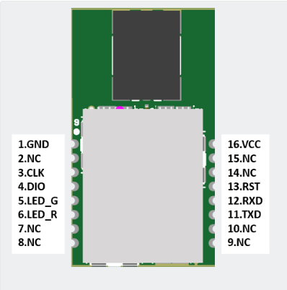
Module Pinout Description 1
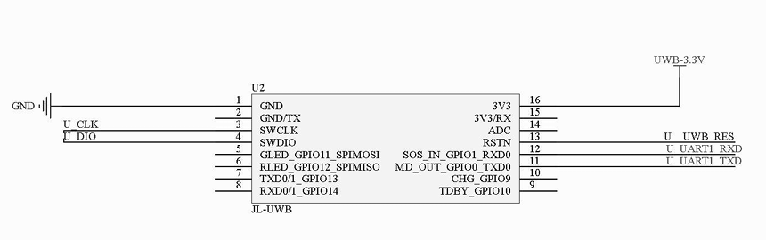
Module Pinout Description 2
Pin | Function
1 | GND
3 | Download CLK
4 | Download DIO
5 | Green status indicator light; power supply is flashing
6 | Red power indicator light; power is on and the light remains lit
2、7、8、9、10、14、15 | NC must be suspended
11 | UART_Tx Pin speed 115200
12 | UART_Rx Pin speed 115200
13 | Reset pin, with low level as the effective signal
16 | Positive power supply terminal is powered by 3.3V

Module hardware packaging dimensions
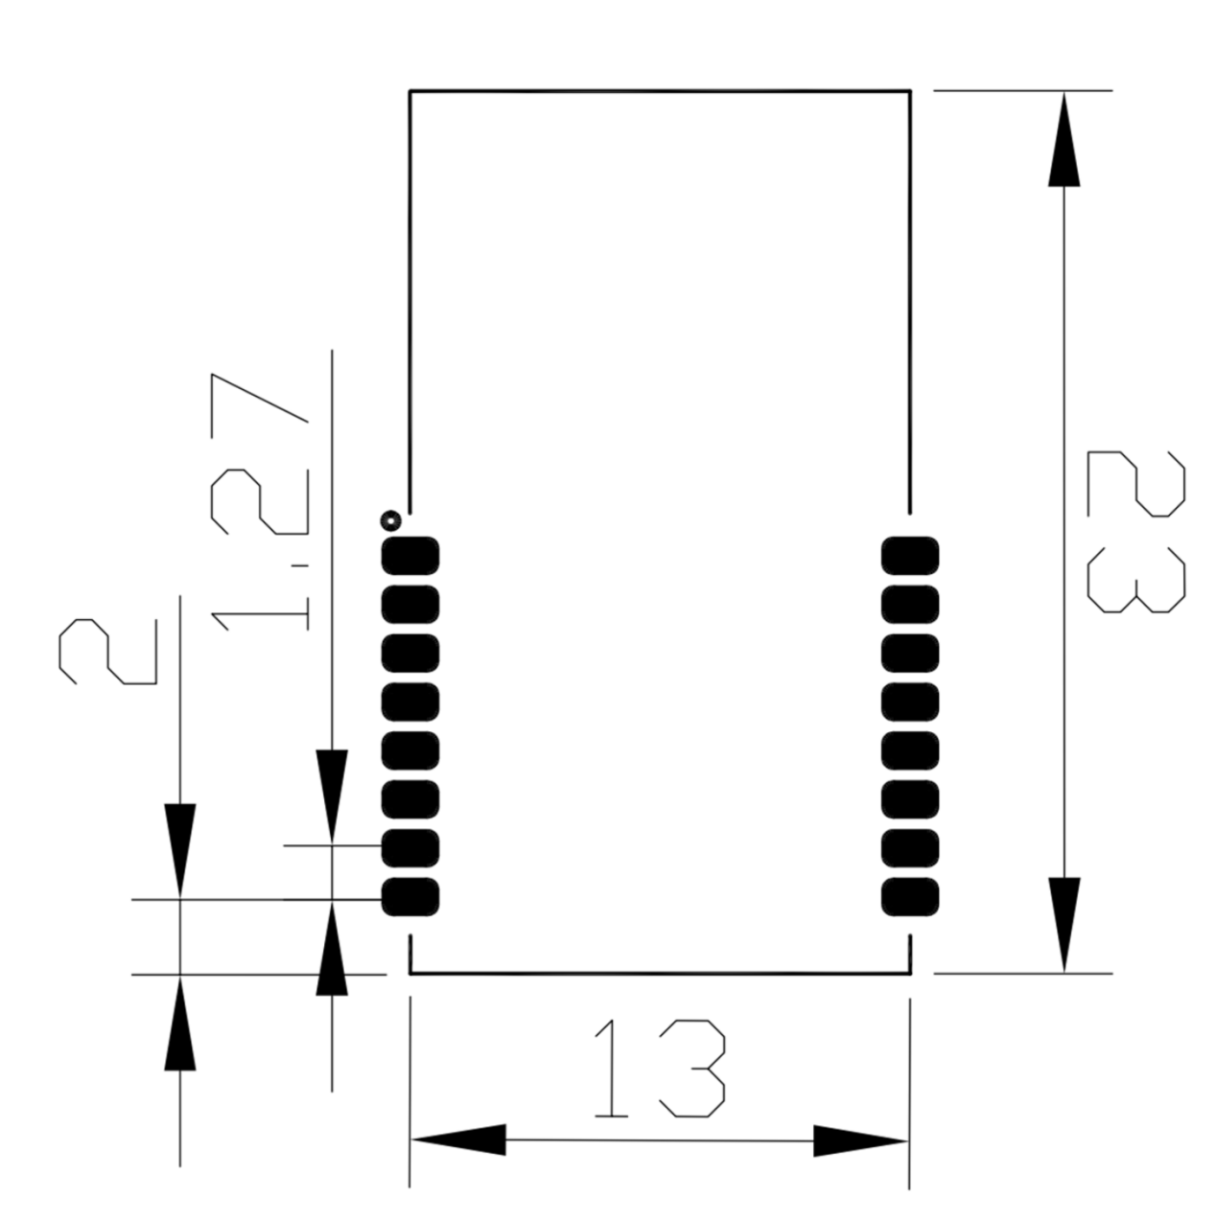
Module size specifications

Communication Protocol Description

Base Station Positioning Frame
Field name | Byte type | Length (Byte) | Index subscript | Function Description
head | uint8_t | 1 | 0 | Fixed header 0x2A
cmd_len | uint16_t | 2 | 1 | Data frame length (length of the fields: cmd_saddr-reserve)
cmd_saddr | uint64_t | 8 | 3 | Self-assigned long address (8 bytes reserved)
cmd_daddr | uint64_t | 8 | 11 | Recipient's full address (8 bytes reserved)
cmd_type | uint8_t | 1 | 19 | Command frame types (1: Base station positioning frame 2: Base station configuration frame 3: Tag configuration frame 4: OTA upgrade frame 5: Whole machine configuration frame 0x64: Base station positioning frame RSSI)
cmd_direct | uint8_t | 1 | 20 | Command frame direction (1: Engine request, 2: Device response, 3: Device request, 4: Engine response, 5: Engine report, 6: Device report)
tag_time | uint32_t | 4 | 21 | Tag communication time
anc_addr16 | Uint16_t | 2 | 25 | The short address of the base station
tag_addr16 | uint16_t | 2 | 27 | The short address of the tag
tag_sn | uint8_t | 1 | 29 | Tag communication sn
tag_mask | uint8_t | 1 | 30 | Tag communication is effective.
tag_a0_filter_angle | int16_t | 2 | 31 | Base station 0 filtering angle (°)
tag_a0_filter_range | uint16_t | 2 | 33 | Base station 0 filtering distance (cm)
tag_a1_filter_angle | int16_t | 2 | 35 | Base station 1 filtering angle (°)
tag_a1_filter_range | uint16_t | 2 | 37 | Base station 1 filtering distance (cm)
tag_a2_filter_angle | int16_t | 2 | 39 | Base station 2 filtering angle (°)
tag_a2_filter_range | uint16_t | 2 | 41 | Base station 2 filtering distance (cm)
tag_a3_filter_angle | int16_t | 2 | 43 | Base station 3 filtering angle (°)
tag_a3_filter_range | uint16_t | 2 | 45 | Base station 3 filtering distance (cm)
tag_detail_para | uint32_t | 4 | 47 | Tag data (tag type / battery power / charging status / remote control status) [Note 1: bit structure]
tag_acc_x | uint16_t | 2 | 51 | Tag acceleration along the x-axis
tag_acc_y | uint16_t | 2 | 53 | Tagged acceleration along the y-axis
tag_acc_z | uint16_t | 2 | 55 | Tagged acceleration along the z-axis
tag_gcc_x | uint16_t | 2 | 57 | Taggy Gyroscope X-axis
tag_gcc_y | uint16_t | 2 | 59 | Taggy Gyroscope Y-axis
tag_gcc_z | uint16_t | 2 | 61 | Taggy Gyroscope Z-axis
self_raw_angle | int16_t | 2 | 63 | The original measurement angle of the object (unfiltered)
self_raw_range | uint16_t | 2 | 65 | The original measurement distance of the object (unfiltered)
self_raw_degree | int32_t | 4 | 67 | Original angle of the tag (used during calibration of the base station)
angle_360 | uint16_t | 2 | 71 | 360° angle (used in conjunction with the entire machine)
angle_dir | uint8_t | 1 | 73 | 360° angle approximate direction (for use with the entire machine)
reserve | uint8_t* | 5 | 74 | Reserve 5 bytes
check | uint8_t | 1 | 79 | Check bit (field: checksum of cmd_saddr-reserve)[Note 2: Checksum calculation program]
foot | uint8_t | 1 | 80 | Fixed trailer byte: 0x23

Base station positioning frame RSSI
Field name | Byte type | Length (Byte) | Index subscript | Function Description
head | uint8_t | 1 | 0 | Fixed header 0x2A
cmd_len | uint16_t | 2 | 1 | Data frame length (length of the fields: cmd_saddr saddr-reserve)
cmd_saddr | uint64_t | 8 | 3 | Self-assigned long address (8 bytes reserved)
cmd_daddr | uint64_t | 8 | 11 | Recipient's full address (8 bytes reserved)
cmd_type | uint8_t | 1 | 19 | Command frame type (1: Base station positioning frame 2: Base station configuration frame 3: Tag configuration frame 4: OTA upgrade frame 5: Whole machine configuration frame 0x64: Base station positioning frame RSSI)
cmd_direct | uint8_t | 1 | 20 | Command frame direction (1: Engine request, 2: Device response, 3: Device request, 4: Engine response, 5: Engine report, 6: Device report)
tag_time | uint32_t | 4 | 21 | Tag communication time
anc_addr16 | Uint16_t | 2 | 25 | The short address of the base station
tag_addr16 | uint16_t | 2 | 27 | The short address of the tag
tag_sn | uint8_t | 1 | 29 | Tag communication sn
tag_mask | uint8_t | 1 | 30 | Tag communication is effective
tag_a0_filter_angle | int16_t | 2 | 31 | Base station 0 filtering angle (°)
tag_a0_filter_range | uint16_t | 2 | 33 | Base station 0 filtering distance (cm)
tag_a0_rssl | int16_t | 2 | 35 | Base station 0 signal strength
tag_a1_filter_angle | int16_t | 2 | 37 | Base station 1 filtering angle (°)
tag_a1_filter_range | uint16_t | 2 | 39 | Base station 1 filtering distance (cm)
tag_a1_rssl | int16_t | 2 | 41 | Base station 1 signal strength
tag_a2_filter_angle | int16_t | 2 | 43 | Base station 2 filtering angle (°)
tag_a2_filter_range | uint16_t | 2 | 45 | Base station 2 filtering distance (cm)
tag_a2_rssl | int16_t | 2 | 47 | Base station 2 signal strength
tag_a3_filter_angle | int16_t | 2 | 49 | Base station 3 filtering angle (°)
tag_a3_filter_range | uint16_t | 2 | 51 | Base station 3 filtering distance (cm)
tag_a3_rssl | int16_t | 2 | 53 | Base station 3 signal strength
tag_detail_para | uint32_t | 4 | 55 | Tag data (tag type / battery power / charging status / remote control status) [Note 1: bit structure]
tag_acc_x | uint16_t | 2 | 59 | Tag acceleration along the x-axis
tag_acc_y | uint16_t | 2 | 61 | Tagged acceleration along the y-axis
tag_acc_z | uint16_t | 2 | 63 | Tagged acceleration along the z-axis
tag_gcc_x | uint16_t | 2 | 65 | Taggy Gyroscope X-axis
tag_gcc_y | uint16_t | 2 | 67 | Taggy Gyroscope Y-axis
tag_gcc_z | uint16_t | 2 | 69 | Taggy Gyroscope Z-axis
self_raw_angle | int16_t | 2 | 71 | The original measurement angle of the object (unfiltered)
self_raw_range | uint16_t | 2 | 73 | The original measurement distance of the object (unfiltered)
self_raw_degree | int32_t | 4 | 75 | Original angle of the tag (used during calibration of the base station)
angle_360 | uint16_t | 2 | 79 | 360° angle (used in conjunction with the entire machine)
angle_dir | uint8_t | 1 | 81 | 360° angle approximate direction (for use with the entire machine)
reserve | uint8_t* | 5 | 82 | Reserve 5 bytes
check | uint8_t | 1 | 87 | Check bit (field: checksum of cmd_saddr-reserve)[Note 2: Checksum calculation program]
foot | uint8_t | 1 | 88 | Fixed trailer byte: 0x23

Tag Configuration Frame
Field name | Byte type | Length (Byte) | Index subscript | Function Description
head | uint8_t | 1 | 0 | Fixed header 0x2A
cmd_len | uint16_t | 2 | 1 | Data frame length (length of the fields: cmd_saddr-reserve)
cmd_saddr | uint64_t | 8 | 3 | Self-assigned long address (8 bytes reserved)
cmd_daddr | uint64_t | 8 | 11 | Recipient's full address (8 bytes reserved)
cmd_type | uint8_t | 1 | 19 | Command frame type (1: Base station positioning frame 2: Base station configuration frame 3: Tag configuration frame 4: OTA upgrade frame 5: Whole machine configuration frame 0x64: Base station positioning frame RSSI)
cmd_direct | uint8_t | 1 | 20 | Command frame direction (1: Engine request, 2: Device response, 3: Device request, 4: Engine response, 5: Engine report, 6: Device report)
config_cmd | uint8_t* | * | * | Configuration command set [Note 4: Label configuration command set]
check | uint8_t | 1 | * | Checksum (Field: checksum of cmd_ saddr-config_cmd) [Note 2: Checksum calculation program]
foot | uint8_t | 1 | * | Fixed trailer byte: 0x23

OTA upgrade frame
Field name | Byte type | Length (Byte) | Index subscript | Function Description
head | uint8_t | 1 | 0 | Fixed header 0x2A
cmd_len | uint16_t | 2 | 1 | Data frame length (length of the fields: cmd and saddr-reserve)
cmd_saddr | uint64_t | 8 | 3 | Self-assigned long address (8 bytes reserved)
cmd_daddr | uint64_t | 8 | 11 | Recipient's full address (8 bytes reserved)
cmd_type | uint8_t | 1 | 19 | Command frame type (1: Base station positioning frame 2: Base station configuration frame 3: Tag configuration frame 4: OTA upgrade frame 5: Whole machine configuration frame 0x64: Base station positioning frame RSSI)
cmd_direct | uint8_t | 1 | 20 | Command frame direction (1: Engine request, 2: Device response, 3: Device request, 4: Engine response, 5: Engine report, 6: Device report)
OTA_cmd | uint8_t* | * | * | OTA commands (developers can ignore this)
check | uint8_t | 1 | * | Checksum (Field: checksum of cmd_ saddr-OTA_cmd) [Note 2: Checksum calculation program]
foot | uint8_t | 1 | * | Fixed trailer byte: 0x23

[Note 1: Bit structure]
【Alarm Status: No/(Remote Control Dedicated) Mode: No/】
0x041A0002 (Hexadecimal) = 0x02001A04 (High-low bit conversion) = 00000010000000000001101000000100 (Binary)
【Alarm Status: Yes/(Remote Control Dedicated) Mode: No/】
0x061A0002 (in hexadecimal) = 0x02001A06 (High-low bit conversion) = 00000010000000000001101000000110 (in binary)
【Alarm status: No / Remote control dedicated mode: Yes / 】
0x241A1002 (in hexadecimal) = 0x02101A24 (High-low bit conversion) = 00000010000100000001101000000110 (in binary)
typedefstruct
{
uint32_tis_lowbattery:1; //Is there a low battery alarm?
uint32_tis_alarm:1; //Is there an alarm?
uint32_tis_chrg:1; //Is charging required?
uint32_tis_tdby:1; //Is it fully charged?
uint32_tbattery_val:10; //Battery voltage 350 = 3.50V
uint32_tis_offset_range_zero_bit:1; //Distance correction position
uint32_tis_offset_pdoa_zero_bit:1; //Angle correction position
uint32_tturn_up:1; //(For remote control use) Forward
uint32_tturn_down:1; //(For remote control use) Backward
uint32_tturn_left:1; //(For remote control use) Left
uint32_tturn_right:1; //(For remote control use) Right
uint32_tmode:3; //(For remote control use) Mode
uint32_trecal:1; //(For remote control use) Recall
uint32_tlock:1; //(For remote control use) Locked
uint32_tdev_type:3; //Device type (0: Learning board 1: Bracelet 2: Remote control)
uint32_treserve:4; //Reserved
}tag_detail_para_t;

[Note 2: Verification calculation program]
Static uint8_t get_Xor_CRC(uint8_t *bytes, int offset, int len)
{
uint8_t xor_crc = 0;
int i;
for (i = 0;i < len; i++) {
xor_crc ^= bytes[offset + i];
}
return xor_crc;
}
[Note 3: Tag Configuration Command Set]
Command | Meaning | Examples
reset | Reset | Reset
rtoken | Restore to factory settings | Restore to factory settings
save | Save | Save settings
saver | Save & Reset | Save & Reset
getver | Get the version
getid | Get the tag ID
setslp(x1) | Set the sleep time of the UWB module(It can be awakened via the serial port) | x1: Sleep duration (unit: milliseconds, -1: complete sleep for 1-n milliseconds)
setsen(x1) | Set the reporting sensor parameters | x1: The parameter corresponds to the tag_detail_para_t (4 bytes) of the base station positioning frame.
[Note 4: Example of Base Station Positioning Frame]
2A 4C 00 DD DD DD DD DD DD DD DD EE EE EE EE EE EE EE EE 01 05 93 23 1C 00 00 00 D8 64 87 01 F9 FF 60 00 00 00 00 00 00 00 00 00 00 00 00 00 FC 17 00 02 00 00 00 00 00 00 00 00 00 00 00 00 F9 FF 60 00 00 00 00 00 45 00 03 00 00 00 00 00 3D 23
Original data | Frame meaning | Data conversion | Index subscript
2A | Frame header |  | 0
4C 00 | Data frame length |  | 1
DD DD DD DD DD DD DD DD | Self-long address (reserved 8 bytes) |  | 3
EE EE EE EE EE EE EE EE | Recipient's full address (8 bytes reserved) |  | 11
01 | Command frame types |  | 19
05 | Command frame direction |  | 20
93 23 1C 00 | Tag communication time |  | 21
00 00 | The short address of the base station |  | 25
D8 64 | The short address of the tag |  | 27
87 | Tag communication sn |  | 29
01 | Tag communication is effective. |  | 30
F9 FF | Base station 0 filtering angle (°) | 0xFFF9 (in hexadecimal) = -6° | 31
60 00 | Base station 0 filtering distance (cm) | 0x0060 (in hexadecimal) = 96 cm | 33
00 00 | Base Station 1 filtering Angle (°) | Reference base station 0 angle conversion | 35
00 00 | Base station 1 filtering distance (cm) | Reference base station 0 distance conversion | 37
00 00 | Base Station 2 filtering Angle (°) | Reference base station 0 angle conversion | 39
00 00 | Base station 2 filtering distance (cm) | Reference base station 0 distance conversion | 41
00 00 | Base Station 3 filtering Angle (°) | Reference base station 0 angle conversion | 43
00 00 | Base station 3 filtering distance (cm) | Reference base station 0 distance conversion | 45
FC 17 00 02 | Tag data (Note 1: Bit structure) |  | 47
00 00 00 00 00 00 | Tagged acceleration along the x-axis/y-axis/z-axis |  | 51
00 00 00 00 00 00 | Tag gyroscope x-axis/y-axis/z-axis |  | 57
F9 FF | The original measurement angle of the object (unfiltered) | Reference base station 0 angle conversion | 63
60 00 | The original measurement distance of the object (unfiltered) | Reference base station 0 distance conversion | 65
00 00 00 00 | Original angle of the label (used during calibration of the base station) |  | 67
45 00 | 360° angle (used in conjunction with the entire machine) | Reference base station 0 angle conversion | 71
03 | 360° angle approximate direction (for use with the entire machine) | Reference base station 0 angle conversion | 73
00 00 00 00 00 | Reserve 5 bytes |  | 74
3D | Check bit |  | 79
23 | Frame trailer |  | 80

